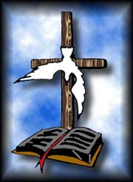 **Institute of Theological Studies**



**Sponsored By**

**KLB MINISTRIES INC.**

**Dr. Kevin L. Betton Sr. *Stay in His Word, His Word is Alive!!!***

**Facilitator**

**Office Phone (912) 876-6489 P.O. Box 1761 Hinesville, GA 31313**

**Fax (912) 876-6406 Email: pastorbetton@coastalnow.net**

**Gifts and Callings of God**

**COURSE OUTLINE**

**Introduction to the Gifts and Callings of God**

* *God doesn't want me "Ignorant"*
* *The Gifts and Callings of God are without Repentance*
* *Purpose of the Gifts*
* *Charismata*
* *Gifts vs. Talents*

**THURSDAY 21st “Gifts from God the Father”**

* *Identify and Interpret the 7 Gifts from the Father*

**FRIDAY 22nd “Gifts from the Son”**

* *Identify and Interpret the Five-fold Ministry Gifts*

**SATURDAY 23rd “Gifts from Holy Ghost”**

* *Identify and Interpret the 9 Gifts from the Holy Ghost*

***“STAY IN HIS WORD BECAUSE HIS WORD IS ALIVE”***