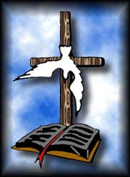 **Institute of Theological Studies**



**Sponsored By**

**KLB MINISTRIES INC.**

***“STAY IN HIS WORD BECAUSE HIS WORD IS ALIVE”***

**Dr. Kevin L. Betton Sr.**

**Facilitator**

**Office Phone (912) 876-6489 P.O. Box 1761 Hinesville, GA 31313**

**Fax (912) 876-6406 Email: pastorbetton@coastalnow.net**

**Gifts and Callings of God**

**SYLLABUS**

**1. COURSE LOCATION:** Course instructions will be given in the Fellowship Hall at the COP 406-C, South Main St. Hinesville, GA., Thur., Sep, 21st; and Fri., Sep 22nd at 6:00pm and Sat., 23rd at 10 am.

**2. INSTRUCTOR:** Dr. Kevin L. Betton Sr. (912) 876-6489 (O).

**3. READING MATERIALS:** Bible; and Handouts.

**4. COURSE OBJECTIVES:** At the conclusion of this course, each student should be able to identify and interpret **21 Gifts and Callings of God** designed for the edification of the Body of Christ.

**5. POLICIES:**

a. Lateness/Absentees

***“Study to show thyself approved unto God,***

***A workman that need not be ashamed…rightly dividing the Word of Truth”***